**Fox - Wooden Animal Wall Mount**

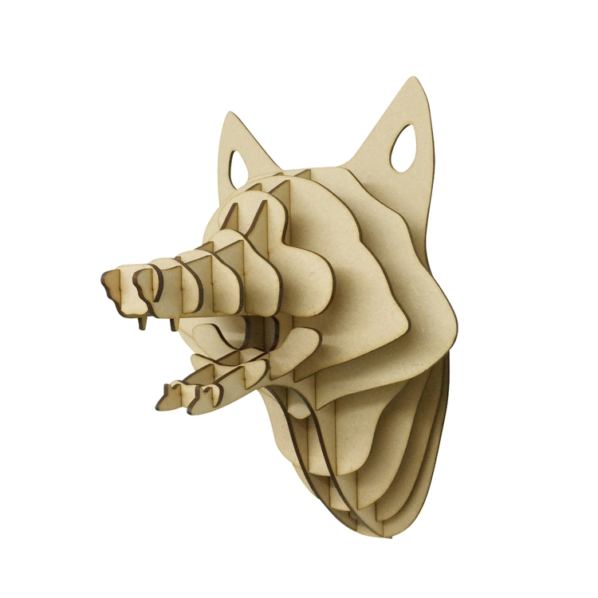The Fox Wooden Animal Wall Mount is a charming and stylish decor piece that adds a touch of woodland elegance to any space. Crafted from high-quality wood, this mount showcases the sleek and playful features of a fox, with intricate detailing that highlights its expressive face and bushy tail. The warm, natural wood tones bring an organic and rustic feel, making it a perfect addition to both contemporary and traditional interiors. Ideal for nature enthusiasts and those seeking a whimsical, yet sophisticated touch to their decor, the Fox Wooden Wall Mount is sure to be a captivating focal point in any room.